Fantasy Pro Tour: Los Angeles - More Picks
Sideboard Staff
RANDY BUEHLER
Sideboard Writer
Magic R&D
If I didn't work at WotC, I would of course send a team in for the Sideboard's Fantasy Pro Tour contest. I think the new format (8-member teams with a 100 Pro Point salary cap) is really cool - so cool that I picked a team even though I'm not eligible. Here's who I would pick:
Dan Silberman - I think Silberman is a no-brainer and belongs on every team. He's one of the original four members of Team CMU and has just as much talent as the rest of us. However, he's chosen to devote himself to college instead of Magic. Last fall he found himself constantly beating up on Mike Turian, Aaron Forsythe, Andrew Cuneo, Andrew Johnson etc. in practice drafts and then those four wound up playing against each other for the Pro Tour New York championship title. Dan decided he should actually try going to a qualifier to see what would happen, found a free weekend, and then drove himself to the nearest qualifier. It turned out the nearest PTQ was 8 hours away in Virginia, but those 8 hours by himself in the car didn't stop him from winning the qualifier! LA will be his PT in several years so he's available for the low low price of 0 PT points.
Dustin Stern - Dustin is another solid player who is part of a solid group of playtesters who doesn't cost very many PT points. He's got 3 in the relevant professional standings, which he got by making the Top 8 at Grand Prix Dallas. He followed that up with a Top 8 at the next (American) Limited Grand Prix earlier this month in New Orleans. After that debut on the Grand Prix circuit it's now time for him to make his Pro Tour debut. With friends/teammates like Mike Hron and Bob Maher teaching him how to draft, look for Dustin to make a run on Day 2 on The Boat.
Truc Bui - My eyes lit up when I saw Truc's name on the invite list. He and his DK-LA teammates (Brian Hacker and John Yoo) taught the world how to draft back in 1997. Their complete mastery on the Mirage-block environment revolutionized everyone's understanding of time advantage and beatdown. Simply put, those were the guys who mastered the art of turning creatures sideways! They also introduced the world to the joys of Magic slang ("janky" and "Props and Slops" are both theirs) and they tallied half a dozen Top 8s to boot. I have no idea if Truc has his game in shape, but he lives in LA so you know he'll show up and the price (0 PT Points) is right.
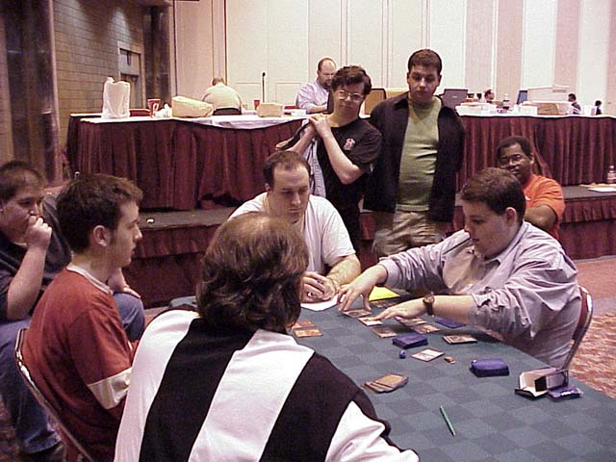
Steve O'Mahoney-Schwartz - Simply put, he's the best Rochester drafter in the world. And he only costs 30 points. His career has been in a small slide lately, but his Top 8 at GP New Orleans proves that he's up on the current set and it's really hard to ignore 1st place and 2nd place finishes at the last two Rochester draft Pro Tours.
Eric Kesselman - A great story and a great player. Kesselman used to be a public defender in Nassau County, New York but he won a few too many cases that he wasn't sure he should have won so he quit, disgusted at the system. He's taken his time finding a new job because he's having so much fun playing Magic 24/7. The regulars at Neutral Ground - New York claim he's every bit as good as anyone else who plays at that legendary store. I think his Grand Prix New Orleans Top 8 was just the beginning. And right now he only costs 8 points!
Ben Rubin - You can make a case for Kai Budde, but I think Ben Rubin is the second best player in the game right now. Rubin is expensive at 41 points, but doesn't single-handedly break the budget the way Finkel does. His one flaw as a player is that he runs hot and cold, rarely making Day 2 without making the Top 8. However, in the Fantasy Pro Tour that's hardly any drawback at all since the money is so top-heavy.
Ron Kotwica - Kotwica is a lesser known Pittsburgh player who made his Pro Tour debut back at PT Mainz, the Rochester draft PT where Matt Place beat Steve OMS in the finals. Ron was playing for Top 8 in the final round, but Peer Kroger won the prestigious slot instead. Kotwica didn't stick on tour, but now he's Qed for another Rochester draft PT and he's been practicing constantly with the guys at CMU so you know he'll be ready. Did I mention he costs 0 points?
Casey McCarrel - McCarrel is better at booster draft than Rochester draft since his style is to keep taking the best cards until he figures out what deck is best for him. However, the price as right at just 16 points. His raw talent has never been questioned.

JEFF DONAIS
Sideboard Publisher
DCI Tournament Manager
1. Dan Silberman (0 points). Dan made the top 8 at Grand Prix Toronto and is a strong younger player from Pittsburgh. Dan was one of the earlier members of team CMU (Carnegie Mellon University in Pittsburgh) and played with such luminaries as Randy Buehler, Nate Heiss, Erik Lauer and Mike Turian. I thought he would be a good deal at zero points.
2. Nate Clarke (2 points). Although Nate has not been consistent lately, he is one of the players with natural talent. I think there is a good chance he will do well at Pro Tour Los Angeles.
3. Kenichi Fujita (4 points). One of the more talented players. I think Fujita will perform well.
4. Eric Kesselman (8 points). Eric is due for a big finish sooner or later.
5. Mark Le Pine (14 points). Le Pine has tons of natural talent and has proved that he can perform well in pressure situations.
6. Kyle Rose (16 points). Kyle is a great deal at 16 points and has performed well in the past. He is a skilled player and a great pick.
7. Gab Tsang (23 points). Gab has made top 8s in the past and has a big pile of talent.
8. Steve O'Mahoney Shwartz (30 points). One of the best players in the game today, I don't mind spending the big points on this OMS.

OMEED DARIANI
Sideboard Content Manager
Satoshi Nakamura 32
One of my favorite players, Satoshi is Japan's most recognizable stars. With his amazing hats and quiet assertive play style, you can't miss him, even in the most crowded room. Nakamura has finished well at his last few Limited events, winning GP Sapporo and placing in the money at GP Kyoto. It's about time for a Japanese player to break into the Top 8 of a Pro Tour - and Satoshi is just the guy to do it.
Aaron Forsythe 28
One of my favorite writers on the internet, Aaron is probably best know as a member of the PT-New York runner-up Car Acrobatic Team. A member of CMU, Aaron is part of a powerful Magic heritage including two Pro Tour winners, one of whom now works in Magic R&D. Aaron is on the short list of people with the skills to win on the Boat.
Kyle Rose 16
Some of my picks are definitely Mid-Atlantic (since I played Magic in Virginia for several years), but Kyle Rose is no slouch. A U.S. National Champion and a Pro Tour winner, Kyle is one of several strong Virginia-area players who have a shot at PT-LA.
Randy Davis 8
I watched this youngster win his share of tough tournaments while judging at Star City Games. He's tough and very skilled at the game. Just to prove that, he took home a cool $4,100 and 13th place at PT-Chicago. For only 8 points, Randy is a bargain.
Chad Ellis 7
Chad is another great writer, whose articles have shown that he has the understanding needed to grasp complicated formats. All the members of Team Your Move Games are potential winners - I wouldn't be surprised to see Chad take it all the way.
Morgan Douglass 4
Another strong player from the Mid-Atlantic, Morgan has also finished in the money at the Pro Tour. Though he isn't well-known on the Pro circuit, he can definitely hang with the big boys and deliver a solid finish.
Dustin Stern 3
Dustin busted out at GP Dallas, proving that he's in the loop, as far as drafting. Dustin seems likely to place in the Top 64. I'd be surprised if he goes all the way, but anything can happen on the boat.
Yoshikazu Ishii 0
Ishii has had several quality performances in the past. After seeing him play at the Magic Invitational, it's very obvious that he's on par with the best Japanese players. Since most of his countrymen cost a few points, getting Ishii for 0 is like Urza's Bauble in the Academy deck. He's broken!
My team comes to 98 points. I'm very happy with the quality of my picks. Los Angeles threw up new talent last year, in Chris Benafel and Trevor Blackwell - it could happen again.

MONTY ASHLEY
Sideboard Managing Editor
I had the luxury of reading my coworkers' picks before making my own. While I agree with many of the picks (who wouldn't be willing to pay zero points for Dan Silberman?), I figure I can't win if my ballot looks the same as everyone else's. The key to winning here is to bet against the rest of the world's picks.
1. Svend Geertsen (12 points): Geertsen did well on the boat when Steve O'Mahoney-Schwartz won in 1998, and has aTop 4 at Worlds to his credit. He's always been able to draft well - see GP Copenhagen.
2. Ben Seck (3 points): At this year's Magic Invitational in Sydney, Seck almost got more coverage than any of the players, being unanimously named MVP for providing so many vital cards for decks and acting as unofficial tour guide. Here's where his karma pays off.
3. Dan O'Mahoney-Schwartz (27 points): Everyone's picking Steve, but Dan's no slouch, finishing fourth in GP Amsterdam a week after his brother got the same result in New Orleans.Dan's a little cheaper than Steve right now, but I have a feeling that could change after Los Angeles.
4. Christopher Manning (5 points): He's good at Question Mark, and that's good enough for me! Plus, I hear his name around a lot.
5. Royce Chai (4 points): It's not his fault you've never heard of him. He's one of Singapore's highest-rated players, and that's no accident.
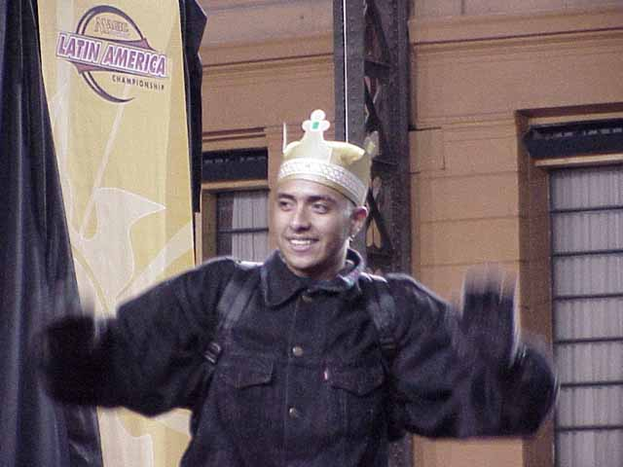
6. Gerardo Godinez (13 points): He's fun to watch. I'm really mostly voting for him because I like the crown he wore after finishing third in the Latin American Championship.
7. Justin Gary (33 points): For a former US National Champion, he doesn't seem to get much respect. Justin, I respect you. Now get out there and win for the fantasy team!
8. Khodadad Azmoon (0 points): You just watch.

Visit the Fantasy PT page here.

